Customer Relationship Management (CRM)

- What is CRM?
Customer Relationship Management (CRM) is a strategy, process, and technology used by organizations to manage and analyze interactions with current and potential customers. CRM systems help businesses store customer data, track interactions, manage sales activities, and improve customer relationships throughout the customer lifecycle.
In simple terms, CRM helps organizations understand their customers better and serve them more effectively.

- Uses of CRM
CRM is used in various business functions, such as:
- Managing customer information (name, contact details, preferences)
- Tracking sales leads and opportunities
- Improving customer service and support
- Automating marketing campaigns
- Monitoring customer interactions across email, calls, social media, and meetings
- Analyzing customer behavior and buying patterns

- Why Organizations Use CRM?
Organizations use CRM to:
- Build strong and long-term customer relationships
- Increase sales and revenue
- Improve customer satisfaction and loyalty
- Centralize customer data in one system
- Improve communication between sales, marketing, and support teams
- Make data-driven business decisions
CRM helps companies stay organized and customer-focused in a competitive market.

- Importance of CRM
The importance of CRM includes:
- Better Customer Understanding: Helps analyze customer needs and preferences
- Improved Customer Retention: Satisfied customers are more likely to return
- Efficient Sales Process: Sales teams can track leads and close deals faster
- Improved Productivity: Automation reduces manual work
- Data Accuracy: Centralized data reduces errors and duplication
- Business Growth: Helps identify opportunities for upselling and cross-selling

- CRM Entities
CRM entities are the main objects or records stored in a CRM system. Common CRM entities include:
- Leads: Potential customers who have shown interest
- Contacts: Individual customers or people related to an account
- Accounts: Companies or organizations that do business with you
- Opportunities: Potential sales deals
- Cases/Tickets: Customer issues or support requests
- Activities: Calls, emails, meetings, and tasks
- Products: Items or services offered
These entities help organize customer-related data efficiently.
- What are CRM Metrics?
CRM metrics are measurements used to evaluate the performance of sales, marketing, and customer service activities.
Common CRM metrics include:
- Customer Acquisition Cost (CAC)
- Customer Lifetime Value (CLV)
- Conversion Rate
- Sales Growth
- Customer Retention Rate
- Churn Rate
- Average Response Time
These metrics help organizations measure success and identify areas for improvement.

- What is Sales Funnel and Sales Pipeline?
  - Sales Funnel
The sales funnel represents the stages a customer goes through before making a purchase. It usually includes:
- Awareness
- Interest
- Consideration
- Decision
- Purchase
It is called a funnel because the number of potential customers reduces at each stage.
  - Sales Pipeline
The sales pipeline is a visual representation of all active sales opportunities and their current stages. It helps sales teams track deals, forecast revenue, and manage sales activities.

- Customer Segmentation and Its Types
Customer segmentation is the process of dividing customers into groups based on similar characteristics. This helps organizations target customers more effectively.
Types of Customer Segmentation:
- Demographic Segmentation
  - Based on age, gender, income, education, occupation
- Geographic Segmentation
  - Based on location such as country, state, city
- Psychographic Segmentation
  - Based on lifestyle, interests, values, and personality
- Behavioral Segmentation
  - Based on buying behavior, usage patterns, and brand loyalty

- Real-World Examples of CRM
      - E-commerce Company (Amazon-like)
An e-commerce company uses CRM to track customer purchases, browsing history, and feedback. Based on this data, the company recommends products, sends personalized offers, and resolves customer complaints quickly. This improves customer satisfaction and increases repeat purchases.
      - Banking Sector
Banks use CRM to manage customer accounts, loans, credit cards, and service requests. CRM helps banks understand customer financial needs and offer suitable products like loans or investment plans.
      - Education or Internship Platform
Education platforms use CRM to track student inquiries, enrollment status, follow-ups, and feedback. This helps counselors convert inquiries into admissions efficiently.

- Diagram Explanation of CRM Concepts
- CRM System Flow
Customer → Sales Team → CRM System → Marketing / Support Team → Customer
- Customer interacts with the company
- All data is stored in CRM
- Teams use the same data to provide better service
- Sales Funnel & Sales Pipeline
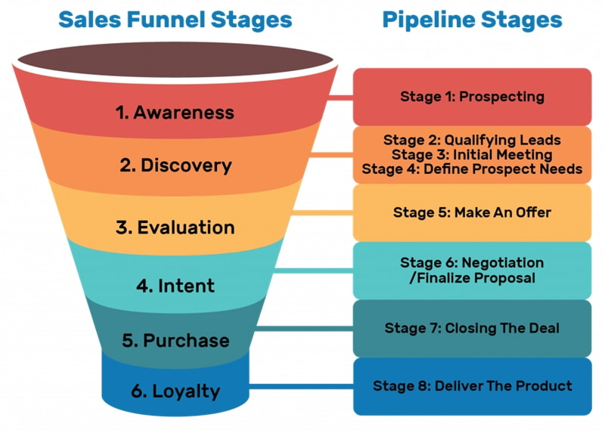
- Customer Segmentation
Customers are divided into groups such as:
- Demographic : Age, Gender
- Geographic : City, Country
- Behavioral : Buying Pattern
Each segment receives targeted communication and offers.

- Conclusion
Customer Relationship Management (CRM) plays a vital role in modern organizations by helping them manage customer interactions, improve satisfaction, and increase business growth. With real-world applications and clear visual understanding, CRM becomes easier to use and more effective for business success. This research report provides both theoretical and practical understanding of CRM concepts, making it suitable for internship and academic purposes.

